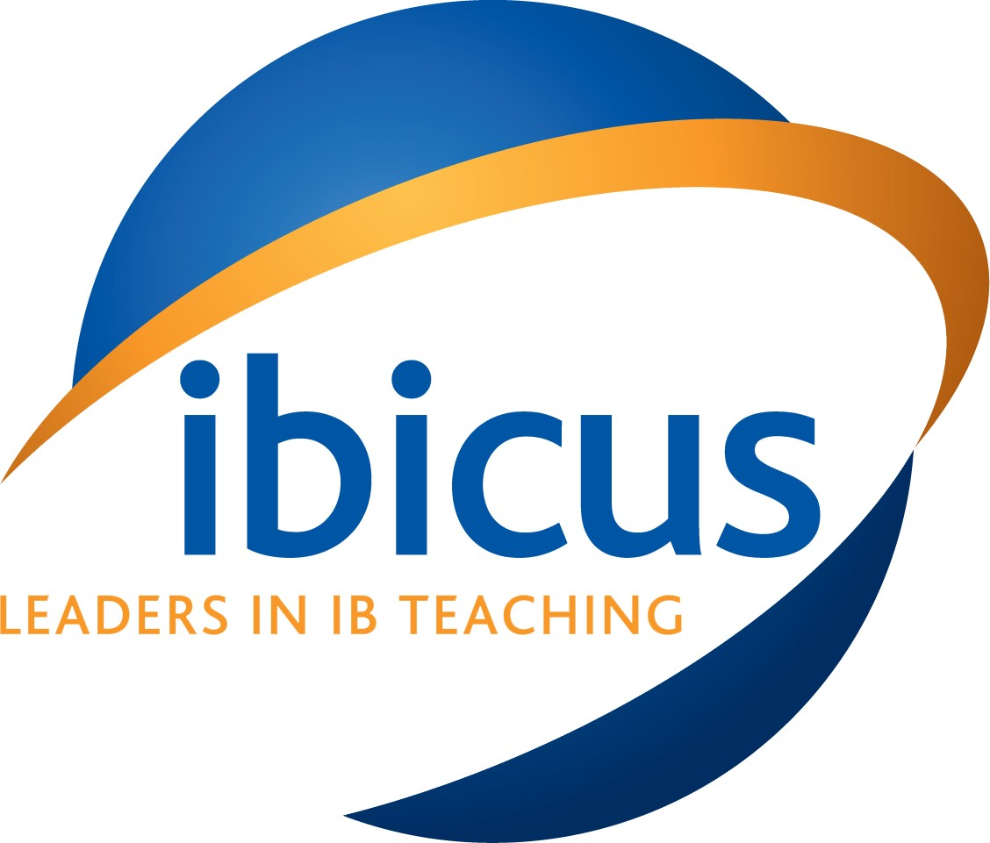

Ibicus Europe Ltd IB Teacher Workshops

International School Prague, Czech Republic

22-24 February 2018

To Whom It May Concern

Ibicus Europe Ltd hereby certifies that

FULL NAME
Gender | Male / Female

Present Citizenship

Date and Place of Birth

Present Country of Residence

Passport Number

Passport Place of Issue

Passport Expiry Date

Occupation

Currently employed at NAME OF EMPLOYER, who are sponsoring their participation at the International Baccalaureate Teacher Training Workshops administered by Ibicus at International School Prague, Prague, on 22-24 Feb 2018.

Ibicus Europe Ltd is grateful for all assistance given to NAME in obtaining an entry visa to the Czech Republic.

Dated ../../....

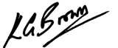

Kevin Brown

Director, Ibicus Europe Limited, 84 Arthur Road, London SW19 7DT, UK

Ibicus.org.uk

Telephone +44 20 8946 0742 / +44 7785 503493

