WORKSHOP VENUE

RAFFLES WORLD ACADEMY (RWA)
Al Marcup Street (formerly Street 7), Umm Suqeim 3, Dubai, United Arab Emirates
Tel: +971 4 4271351/2 / local dial: 04 427 1351/2

Getting there
If arriving by car, there is plenty of parking available at the front of the school.
Driving Directions: Head for Junction 4 (exit 39) on the Sheikh Zayed Road, signposted D63 Umm Suqeim Road (West), also signposted for the Burj Al Arab and Madinat Jumeirah. At the main junction at the end of Umm Suqeim Road, turn right into (302) Jumeirah Beach Road, heading towards Dubai and the Burj al Arab/Jumeirah Beach Hotel. Turn right at the Emirates Bank (directly opposite the Burj al Arab). At the end of the road, turn left and then second right into Al Marcup Street. The Raffles World Academy is on Al Marcup Street on the right hand side.
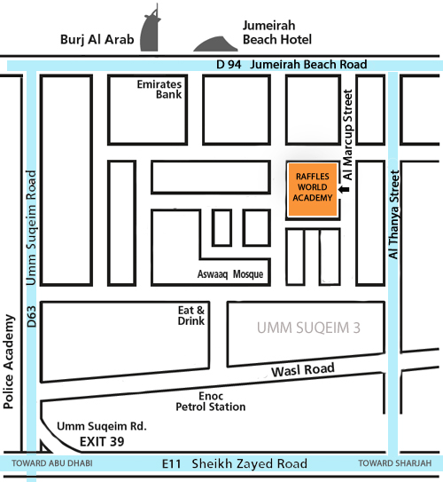
If you are staying at our recommended workshop hotel, the Novotel Al Barsha – there will be buses to transport you to the workshop and back to the hotel each day. Please note that these are only for residents of the hotel and we appreciate your cooperation in this.
If you are not staying at the Novotel Al Barsha – please take a taxi.
Taxis are plentiful and reasonably priced in Dubai.
Dubai Taxi Corporation
+971 4 208 0808 /
local dial 04 208 0808
or you can use the Careem chauffeur cab booking service by downloading the Careem app on your smartphone
You may find it helpful to print out the map to show the taxi driver

